1.

Graphic design is a graphical representation of visuals in the form of posters, images, photographs, designs etc. Dieter rams a stalwart in the field advocated for minimalist designs.

He gave the good design law which is crucial to follow his motto less is better. He included a total of 10 elements in the same.

It includes concepts like color theory, color mixing models, typography etc.

Software like illustrator, photoshop etc. are used for the same.

In today’s data and technology driven world, graphic design is essential—not just for aesthetics, but for clear, effective visual communication. With constant content flooding our screens through social media, websites, and apps, good design helps brands stand out, build trust, and connect emotionally with audiences. It also improves user experience by making information easy to navigate and aesthetically engaging. According to Adobe’s *State of Create* report, 59% of people prefer content that is well-designed, even when short on time. Beyond marketing, design has the power to inspire change—seen in movements like Black Lives Matter, where bold visuals entailing BLM posters sparked global awareness.

In short, graphic design is very effective in creating visuals that aid multiple endeavors.

2.

Graphic design plays a quintessential role across several fields, shaping how information is communicated. In advertising, design is key for expanding company exposure and delivering persuasive and attractive messages, whether through social media graphics, billboards, or digital ads. A well-designed visual can make a campaign more memorable and increase consumer engagement, as highlighted by the American Marketing Association. In the realm of web design and user interface (UI), graphic design ensures that websites and apps are both aesthetically pleasing and easy to navigate. Clean layouts, thoughtful typography, and intuitive icons contribute to a better user experience and increased engagement, as noted by *Smashing Magazine*. Another major area is branding, where graphic design helps define a company’s identity through logos, color schemes, and visual schemes. A consistent, well-crafted brand image builds trust and recognition, which can directly influence consumer loyalty and revenue-*Forbes* reports that consistent branding can boost revenue by over 20%. Across these fields, graphic design is more than art-it’s a strategic tool for communication and business growth.

3.

**Line:** it is a path that connects two points. It can vary in length, thickness etc.

**Value:** it denotes lightness and darkness of colour.

**Shape:** enclosed figures which can be geometrical or irregular.

**Form:** 3 dimensional objects made using perspective and lightning

**Space:** it is the empty area around, between, and within objects.

**Texture:** it is how an objects feels on the surface, smooth or rough

**Color:** Designers work with hue (base colour ), saturation (intensity), and value (lightness or darkness). Color theory helps designers choose effective palettes.

4.

**Line:**

If u deign to make a website , horizontal lines can separate sections (like the header from the body). U can make a grid with lines if the project calls for it.

Shapes like geometrical ones can be used in logos

**Form:**

u can show how a box will look while designing a product.

Space for minimalistic designs and posters, space plays a crucial role in improving readability.

**Texture :**

when a paper or grain texture is used in a brochure, it gives a tactile quality to the print

**Color:**

To make ur design more aesthetically pleasing, in a poster vibrant colours have a great effect on their marketability

**Value:**

Used to create shadows in UI design.

5.

**Balance:** it defines how the visual weight of objects is distributed on an interface.

**Contrast:** when opposing objects in their color texture, or form are kept together.

**Emphasis:** It is when one of the elements are made to stand out.

**Movement:** It guides the viewer’s eye through a design, lines and positioning is used for the same.

**Pattern :** They are repetitive objects in a design.

**Rhythm:** is when elements are repeated at specific intervals

**Unity:** It ensures that all objects work together in a design and nothing seems out of place.

6.

Design isn’t just about making things look nice, it’s about making them work, feel right, and communicate clearly. The core principles of design—**balance, contrast, emphasis, movement, pattern, rhythm, and unity**—help you to do just that. **Balance** gives a sense of stability, like when everything on a page feels well-placed and easy on the eyes. **Contrast** adds interest by highlighting differences—like bold text on a light background—so important elements would stand out. **Emphasis** helps direct attention, making sure your eyes land exactly where the designer wants them, whether it’s a logo, a headline, or a call-to-action button. **Movement** guides how we naturally explore a design, leading us from one point to the next like a visual path. **Pattern** and **rhythm** introduce repetition and flow, creating consistency and helping things feel organized and familiar. And **unity** brings everything together—colors, fonts, images—so the design feels like one complete, cohesive message. When these principles work in harmony, they create designs that not only look beautiful but also feel intuitive and meaningful.

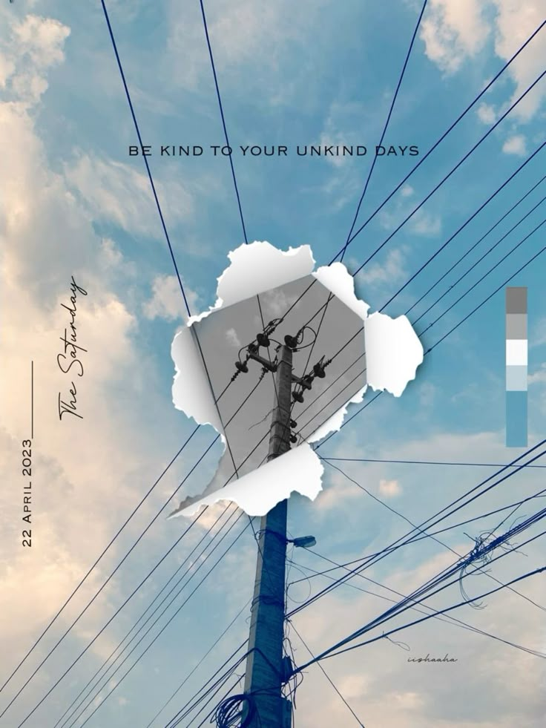

7.

The torn paper shows texture

Lines are used against the electricity pole

Colors are used to denote different elements

There is unity among all elements

The pole is made through a rectangular shape

Value can be seen with the lightness and darkness of the color blue

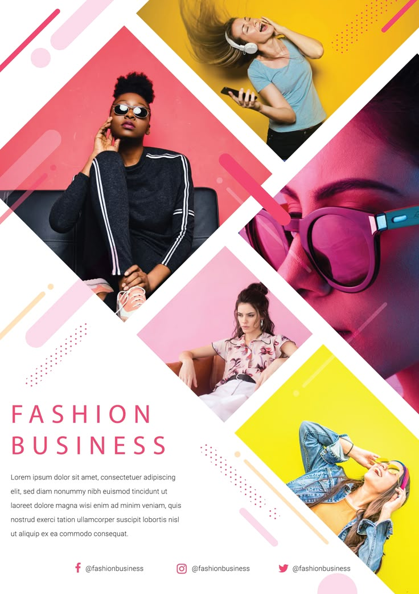

8.

Shapes are used to create the pattern.

Contrast is used with a lot of vibrant colors

Space is smartly used in this to create a minimalistic design

There is a rhythm since the shape elements keep repeating at intervals

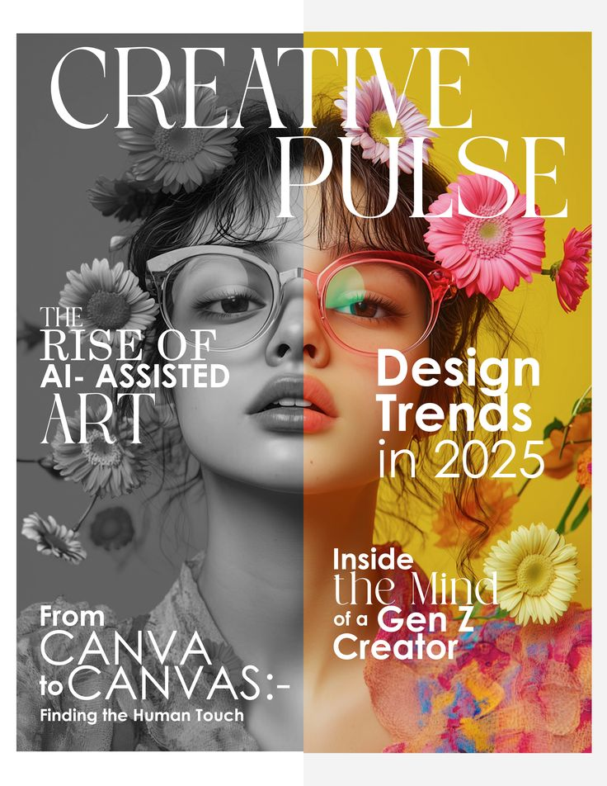

9.

The colour and black contrast in the design can be seen.

Value can be seen from a grayscale and one vibrant portion.

Emphasis: The creative pulse headline is made to stand out.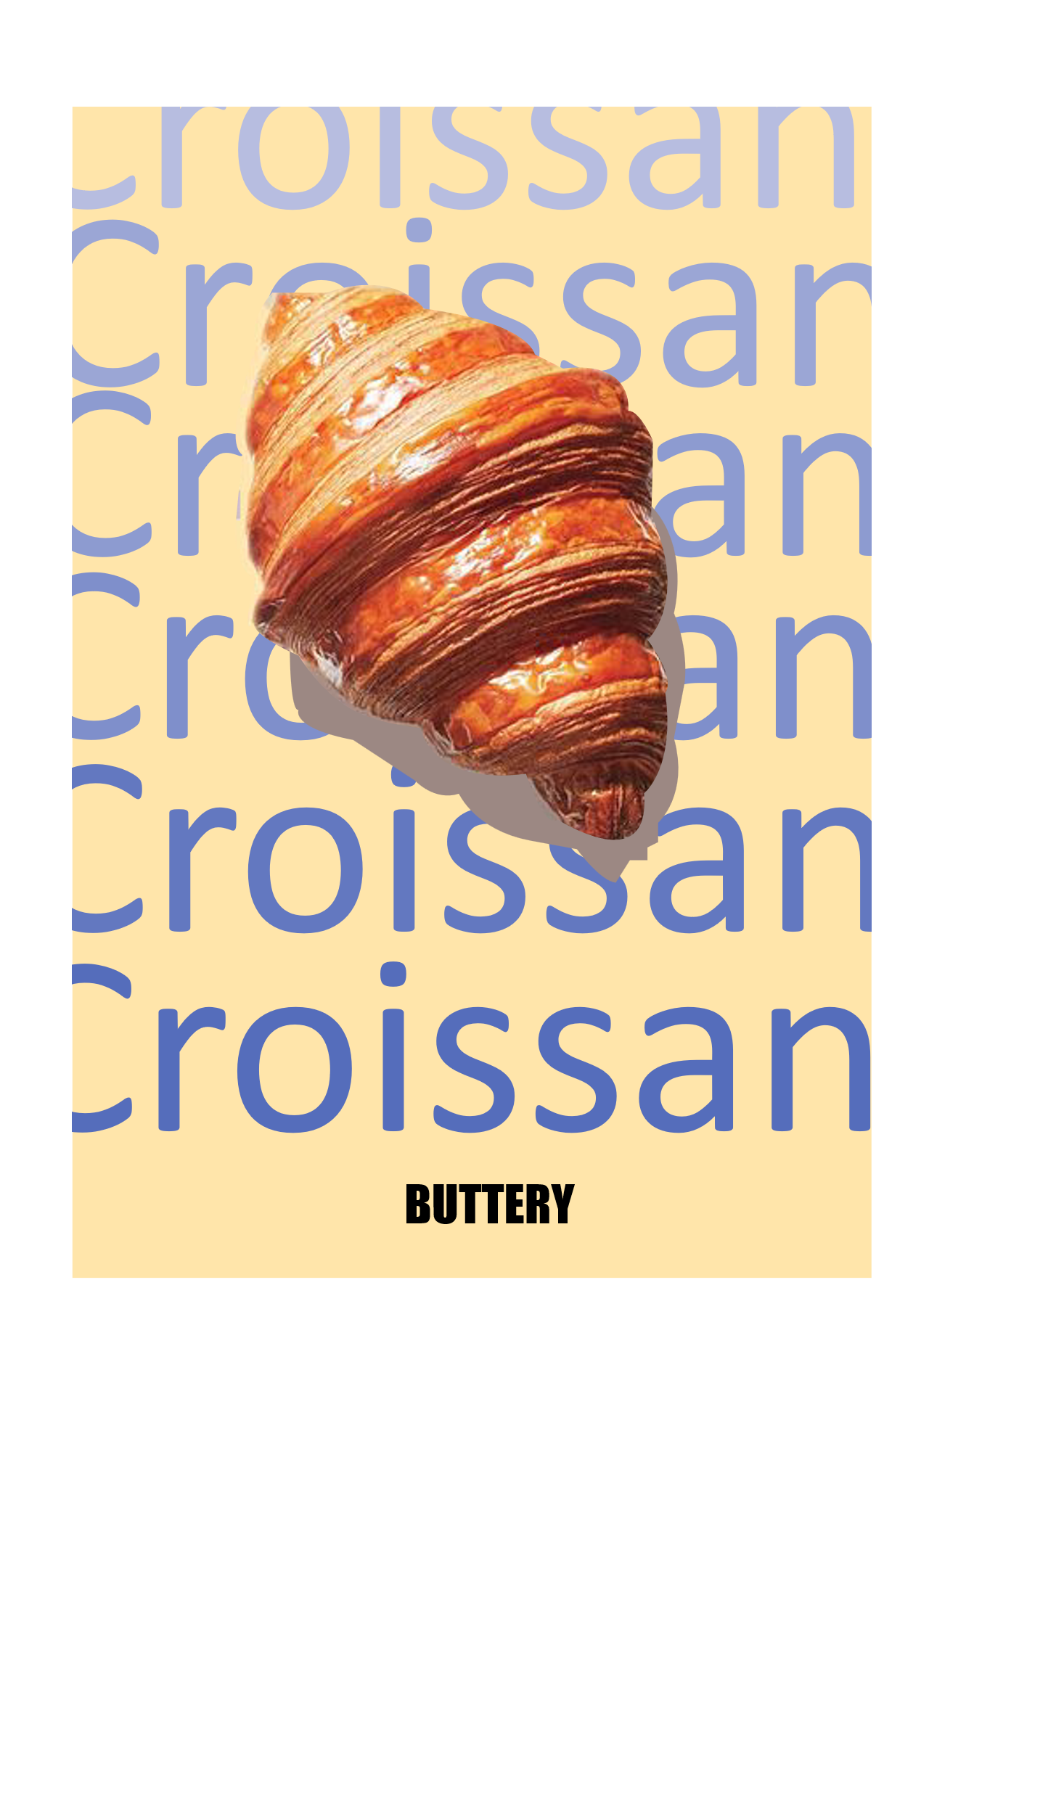

10.

Color plays a crucial role in shaping perception and behavior in design by evoking emotional responses, attracting attention, and influencing decision-making. Warm colors like red and orange can stimulate excitement or urgency, often used in sales or call-to-action buttons, while cool tones like blue and green tend to promote calmness, trust, and stability—common in healthcare and finance branding. According to a 2006 study published in *Management Decision*, up to 90% of quick judgments about products can be based on color alone, depending on the context (Labrecque & Milne, 2012) which signifies its effect. Designers use color strategically to convey brand identity, set mood, and enhance user experience, making it an essential element in visual communication.

11.

Red is the color of blood and signifies war and bloodshed, it makes one energetic.

Blue as the color tends to Monday blues it refers to a kind of gloom or sadness.

Yellow is the color of sunshine and it signifies warmth and happiness.

Green: signifies growth and safety

Black: is the color of murk and darkness. It also signifies power and mystery.

and white is the color of peace and tranquil.

12.

**Primary colors:** basic hues not created by mixing other colors. Red blue yellow

**Secondary colors:** made by mixing two primary colors like red and yellow creates orange.

**Tertiary colors**: made with a neighboring secondary color.

13.

**Hue:** it is the base color without any additives.

**Saturation:** it refers to the intensity of a color, saturated colors are bright while unsaturated colors are dull.

**Brightness:** lightness or darkness of a color.

14.

**Monochromatic Colors:** single hue color scheme.

**Analogous Colors**: colors side by side on a color wheel.

**Complementary Colors**: located opposite of each other.

**Triadic Colors**: set of three colors evenly spaced on a wheel.

15.

RGB is an additive model of red blue and green colors. Used in digital screens and produces white when all three are mixed at highest intensity. It is Light -based.

CMYK is ink.

CMYK is primarily used for print because it follows the subtractive color model, where inks absorb (subtract) certain wavelengths of light. When magenta, and black are layered on paper, they reflect specific colors and absorb others, which is ideal for materials that rely on reflected light like posters, magazines, and packaging. In contrast, RGB is used for digital screens because it follows the additive color model, where red, green, and blue light combine to create a wide range of colors. Since screens emit light, adding RGB values increases brightness and produces vivid colors. RGB offers a wider color range than CMYK, making it better suited for digital displays, while CMYK ensures more accurate color reproduction in printing.

16.

Pantone and HEX colors are two different systems used to define colors in print and digital design. Pantone colors come from the Pantone Matching System (PMS), a standardized set of pre-mixed ink colors used mainly in printing to ensure color consistency across different materials, making it ideal for logos, packaging, and branding. Each Pantone color has a unique code (e.g., Pantone 186 C) and is created with specific ink formulation rather than mixing CMYK . In contrast, HEX colors are six-digit alphanumeric codes (e.g., #FF5733) used in digital design to represent colors on screens through combinations of red, green, and blue (RGB) values in hexadecimal numbers. HEX codes are widely used in web development and ensure consistent color display all across.

17.

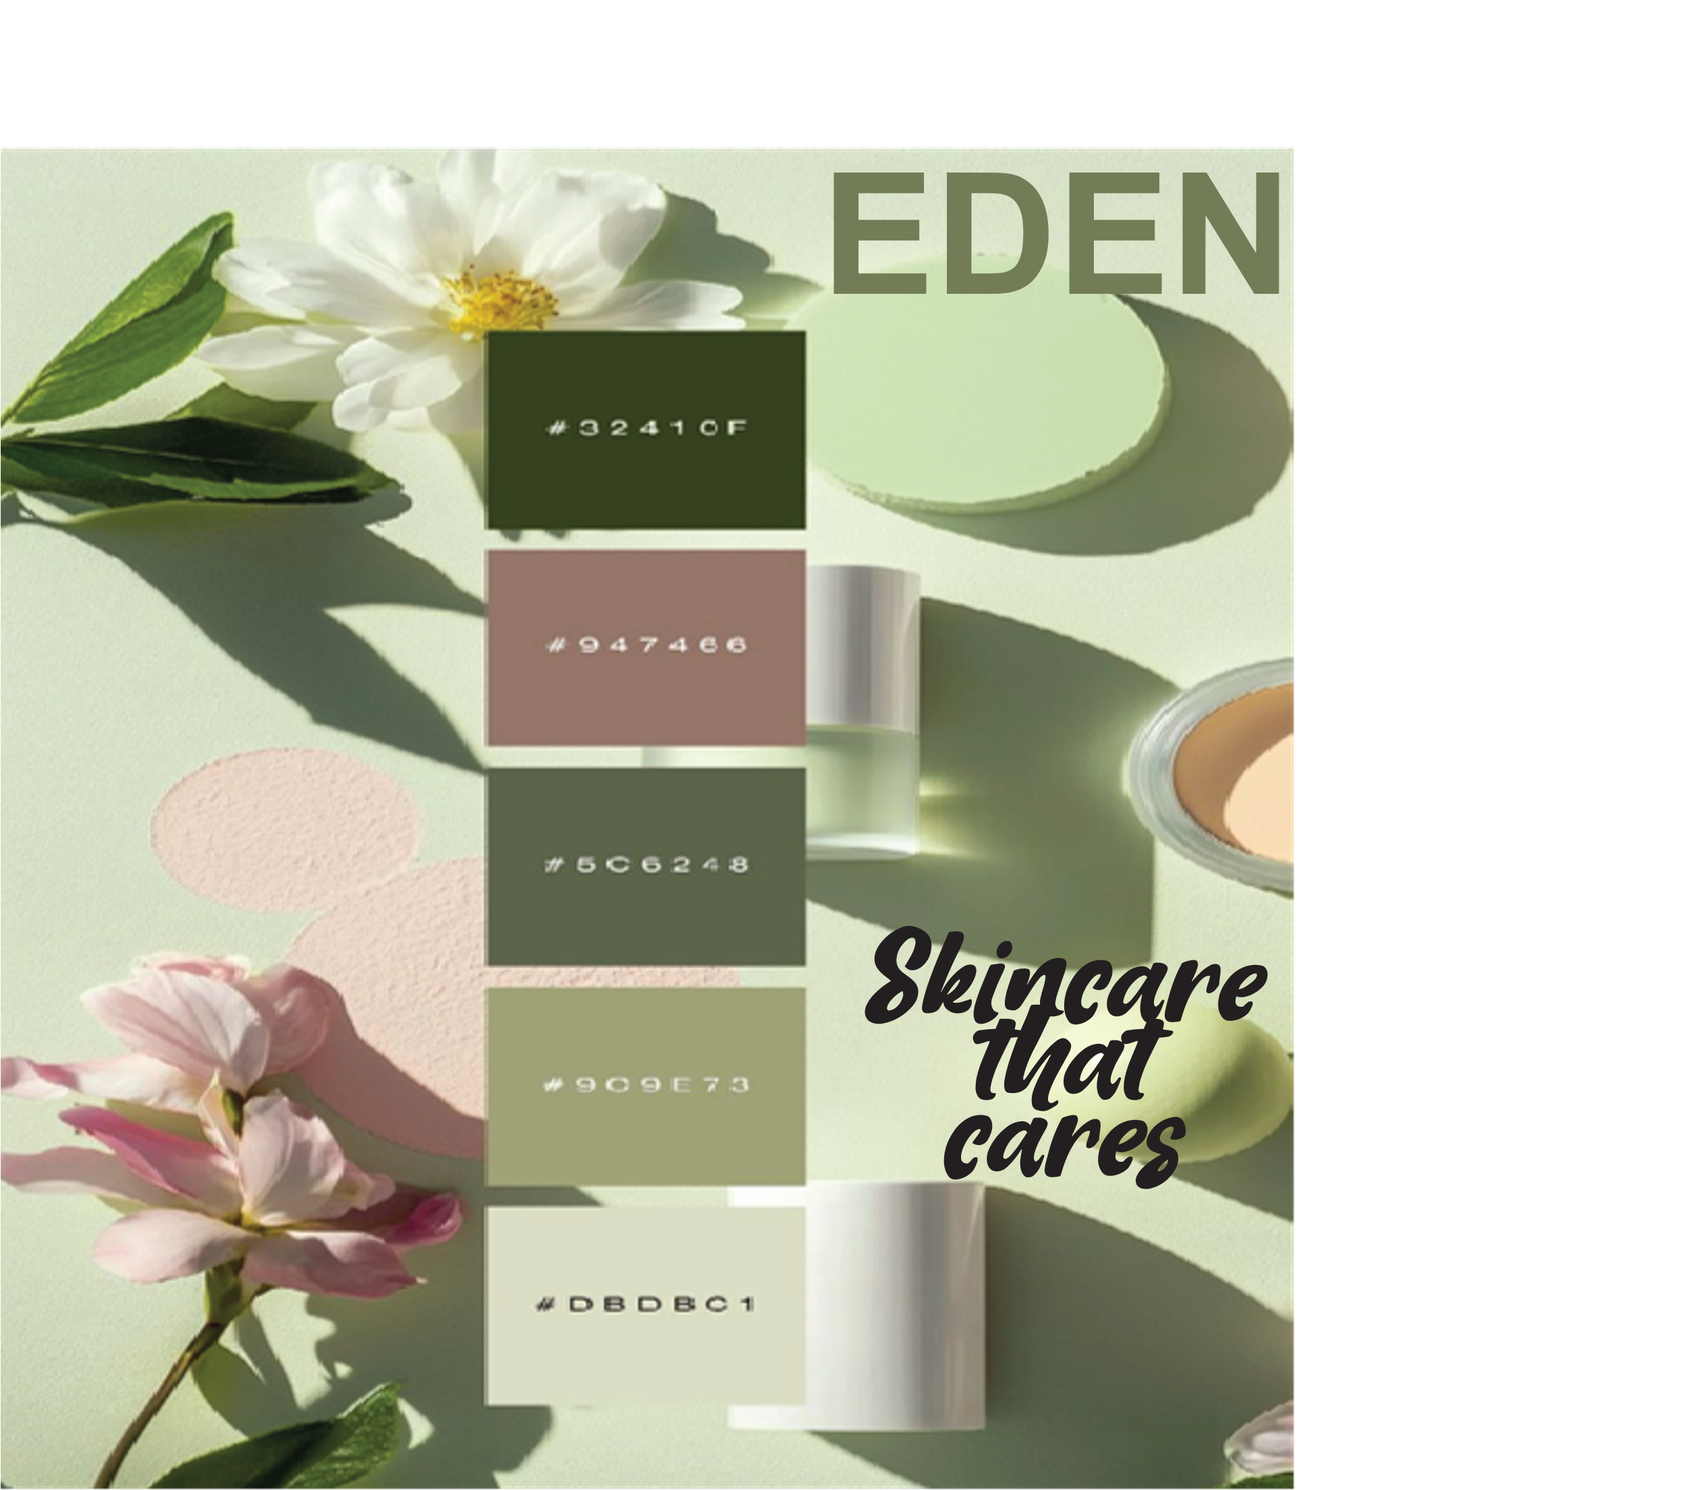

*the color scheme is analogous to the color green and signifies how everything is closely related in taking care of your skin and how ecofriendly the company products are.*

*18.*

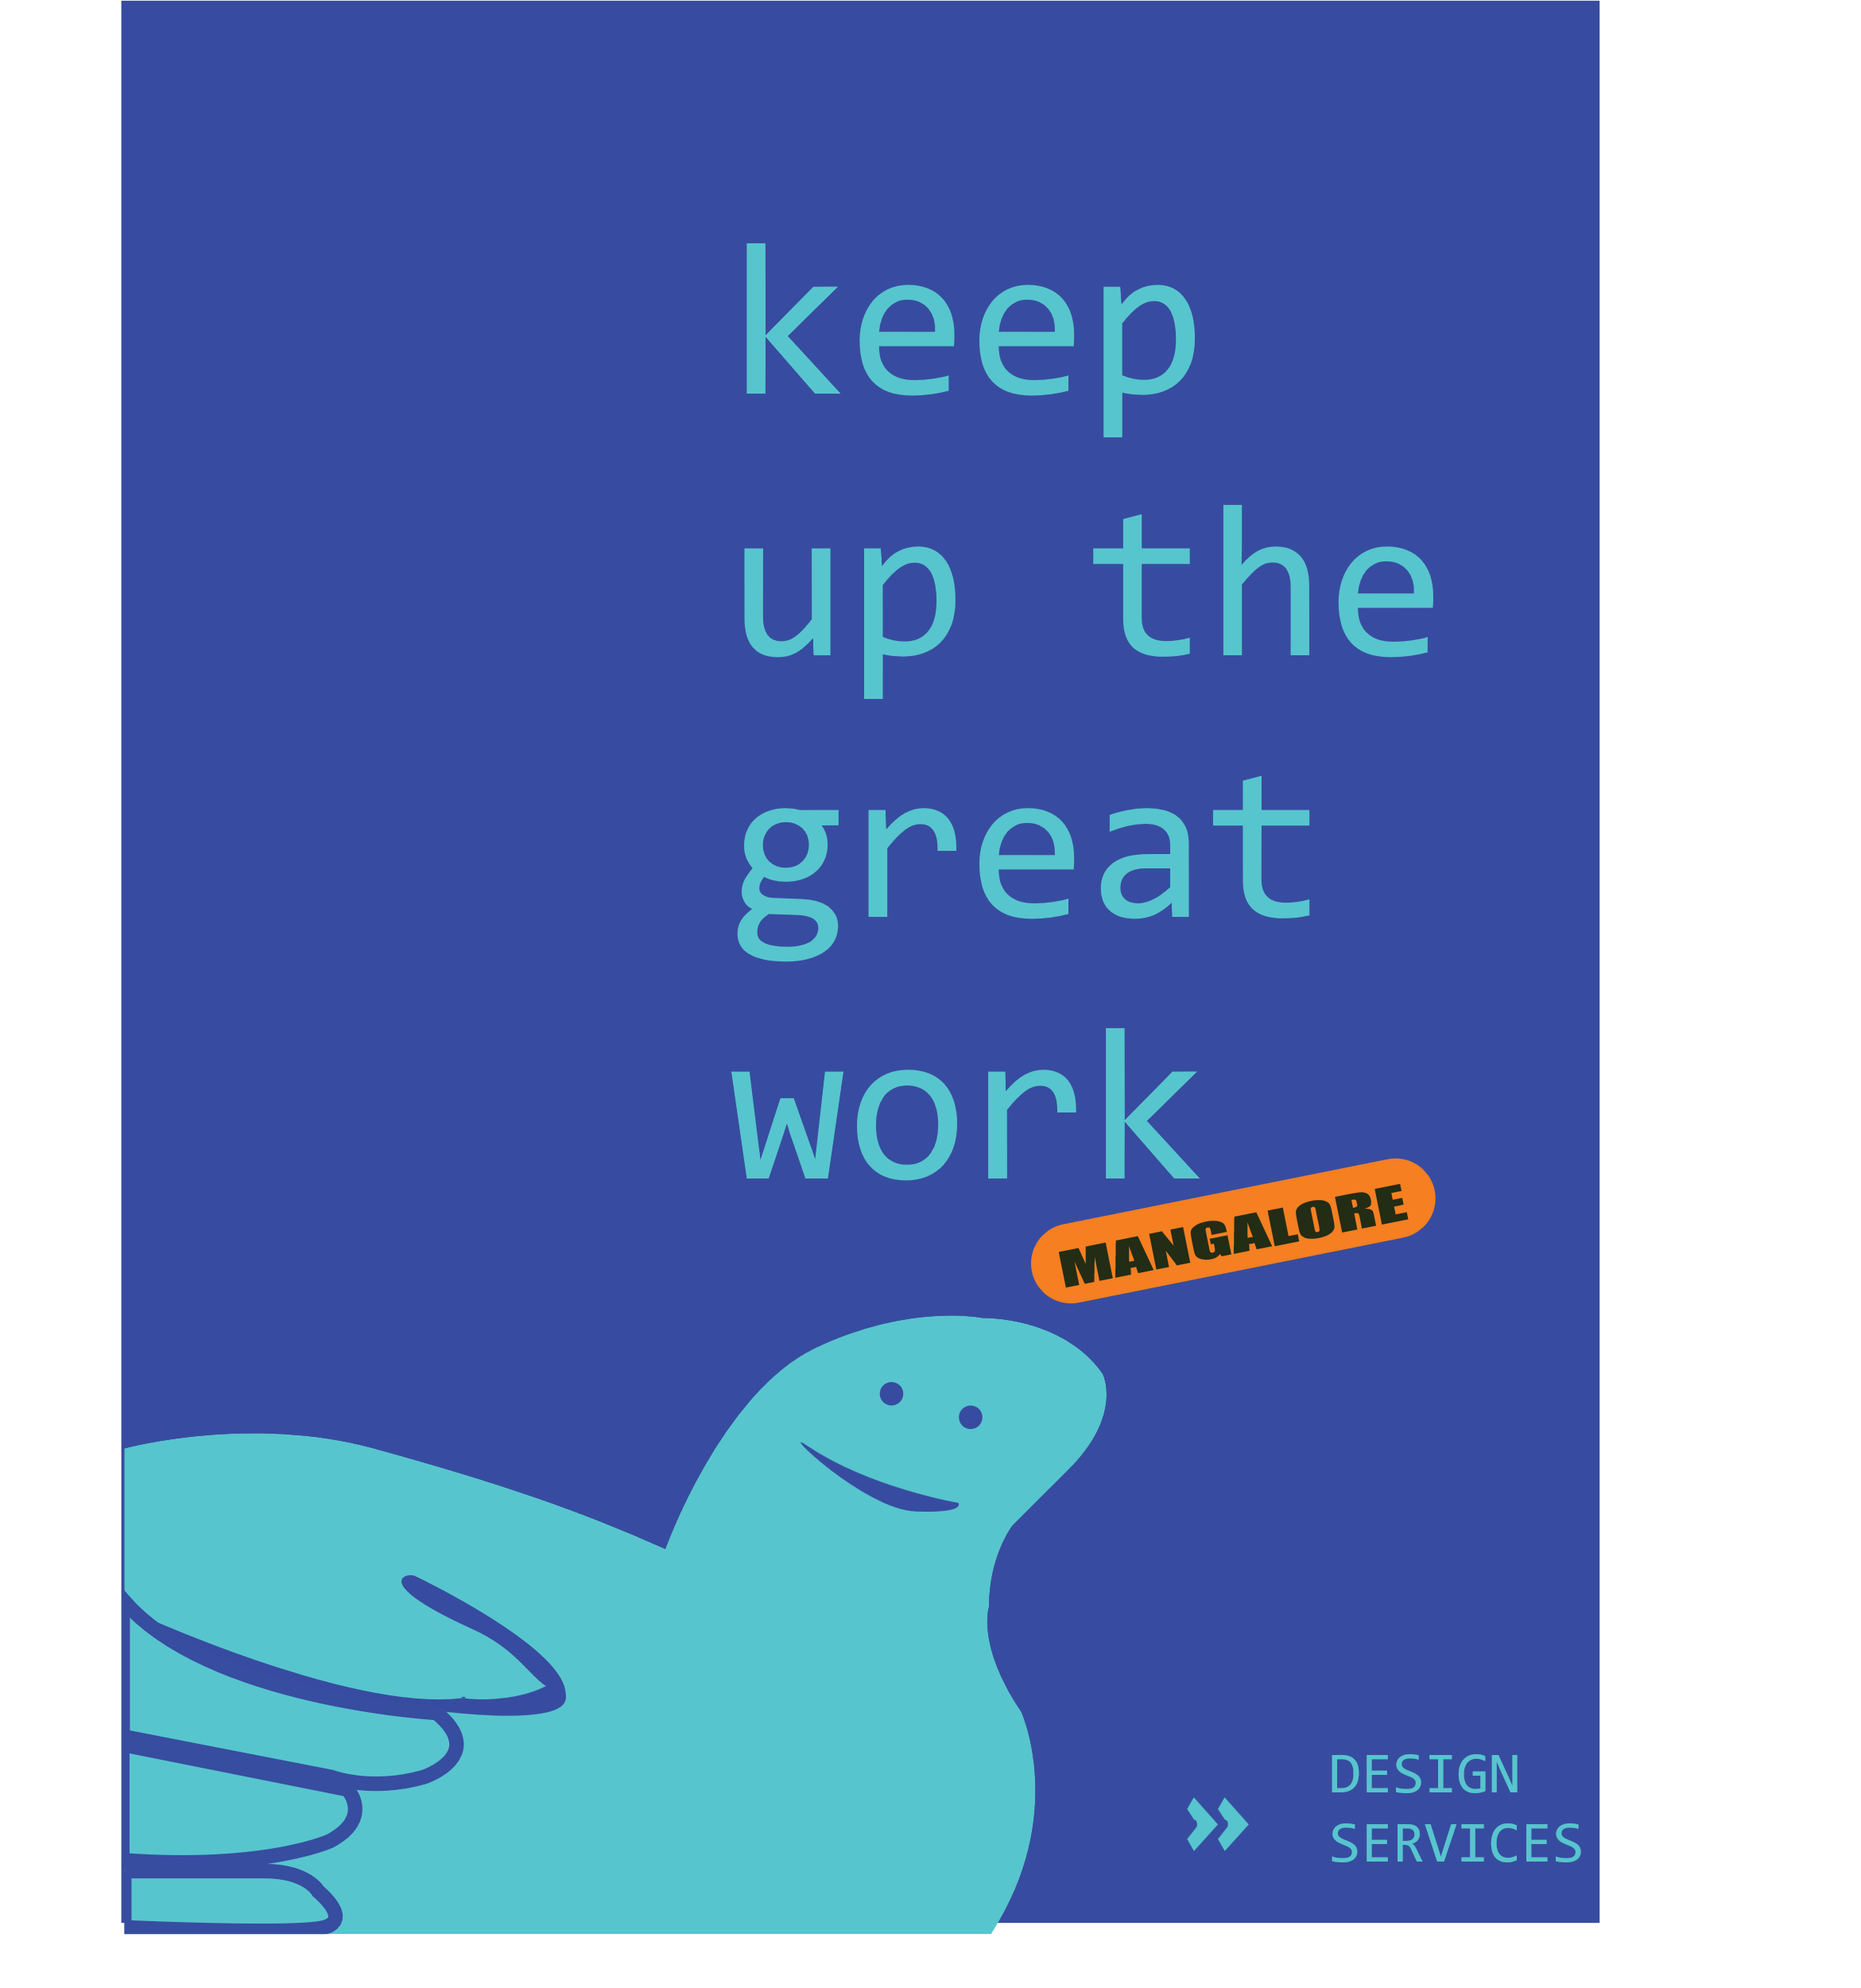

*ITS AN INDIRECT PRAISE TO MANGALORE’S DESIGN SERVICES SINCE BLUE REPRESENTS CALM.*

*19.*

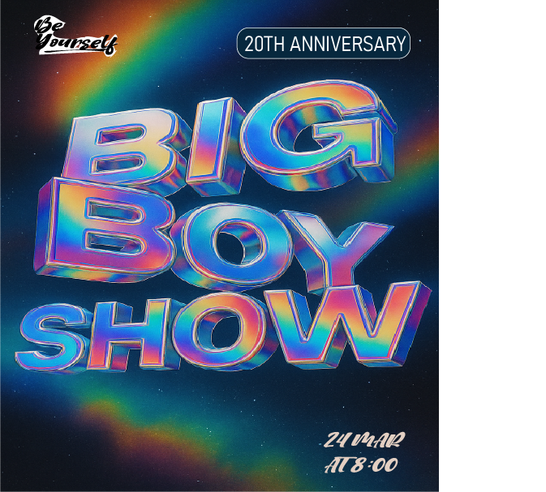

*20.*

**Typeface:** how the text looks and feels e.g.: Times Roman, Ariel

**Font:** the type, shape size of the alphabets

**Serif:** strokes attached to ends of a letter generally decorative

**Sans-serif:** no decorative strokes at the end of the letters

**Kerning:** space between each individual letters

**Leading**: line spacing

**Tracking**: even spacing between all letters

**Baseline:** place where all letters rest includes ascenders and descenders.

*21.*

The main difference between OTF (OpenType Font) and TTF (TrueType Font) comes down to how they're built and what they can do. TTF, originally developed by Apple and later adopted by Microsoft, has a simpler structure and is great for clear text on screens. It’s widely compatible, so it works smoothly across different systems—perfect for everyday digital use.

OTF, on the other hand, is a more modern format created by Adobe and Microsoft. It goes beyond just displaying text by supporting advanced features like ligatures, alternate characters, small caps, and multiple languages. This makes OTF a favorite among designers and publishers who need those extra touches for professional, polished layouts. Both formats are cross-platform, but OTF often wins out when it comes to flexibility and high-end typography.

22.

Serif, sans-serif, script, and decorative are four primary typeface categories, each with distinct characteristics and uses. **Serif** typefaces have small strokes or at the ends of letters, giving them a classic and readable look, especially in print—examples include Times New Roman and Garamond. In contrast, **sans-serif** typefaces lack these strokes, resulting in a cleaner, more modern appearance suited for digital screens, with popular examples like Arial and Helvetica. **Script** typefaces imitate cursive handwriting or calligraphy, offering elegance and personality, often used in invitations or branding—examples include Brush Script and Lobster. Lastly, **decorative** typefaces, also known as display fonts, are highly stylized and designed to stand out in headlines, posters, or logos, such as Jokerman or Papyrus.

*23.*

Serif typefaces are best for print materials like books or newspapers, offering a traditional and readable style. Sans-serif fonts are ideal for digital design and modern branding due to their clean and simple appearance. Script typefaces add elegance and are suitable for invitations, logos, or anything needing a personal touch. Decorative fonts are used for bold, eye-catching designs like posters or headlines, but should be avoided in body text.

24.

In recent years, emerging font types have evolved to meet the demands of modern technology, branding, and user experience. **Variable fonts**, for example, are a major innovation—allowing a single font file to behave like multiple weights and styles, optimizing web performance. **Responsive typefaces** adapt to different screen sizes and resolutions, improving legibility across devices. **Geometric and neo-grotesque typefaces** are gaining popularity in tech branding for their sleek, minimal aesthetic. Additionally, **custom fonts**—uniquely created for brands—are on the rise, offering distinct visual identity in competitive markets. These emerging type styles reflect a shift toward adaptability, efficiency, and stronger brand storytelling.

25.

Typography significantly influences readability, hierarchy, and aesthetics in design. The choice of typeface, size, spacing, and alignment directly affects how easily text can be read—serif fonts often improve legibility in print, while sans-serifs work better on screens. Typography also establishes visual hierarchy by using variations in weight and size to guide the viewer’s attention, helping distinguish headings from body text. Beyond function, typography shapes the overall aesthetic and emotional tone of a design; for example, script fonts can evoke elegance, while bold sans-serifs suggest modernity and clarity. Effective typography ensures that design is not only visually appealing but also functional and communicative.

26.

Typography significantly influences readability, hierarchy, and aesthetics in design. The choice of typeface, size, spacing, and alignment directly affects how easily text can be read—serif fonts often improve legibility in print, while sans-serifs work better on screens. Typography also establishes visual hierarchy by using variations in weight and size to guide the viewer’s attention, helping distinguish headings from body text. Beyond function, typography shapes the overall aesthetic and emotional tone of a design; for example, script fonts can evoke elegance, while bold sans-serifs suggest modernity and clarity. Effective typography ensures that design is not only visually appealing but also functional and communicative.

27.

A grid system in graphic design is like a collection of horizontal and vertical lines spaced out evenly making sure everything feels balanced and easy to read. Designers use grids to create a sense of consistency and flow, so viewers can naturally follow the content without feeling lost. Whether it’s a magazine, a website, or a poster, grids help create structure with creativity.

28.

In graphic design, different types of grid layouts help organize content effectively depending on the project’s needs. A **column grid** divides the page into vertical columns and is commonly used in newspapers and magazines to align text and images. A **modular grid** adds rows to columns, creating a matrix of blocks or modules—ideal for layouts with varied content, like product catalogs or web pages. A **hierarchical grid** is more flexible and organic, adjusting to the content’s flow rather than following strict rows or columns, making it suitable for dynamic designs like editorial spreads or modern websites. Each grid type brings structure, balance, and visual clarity to design while supporting creativity.

29.

**Symmetrical balance** and **asymmetrical balance** are two key approaches to achieving visual harmony in design.

**Symmetrical balance** occurs when elements are evenly distributed on either side of a central axis, creating a mirror-like effect. This type of balance feels formal like everything’s in order, and is often used in traditional layouts like wedding invitations or classical architecture. It evokes a sense of calm and structure.

**Asymmetrical balance**, on the other hand, involves arranging elements of varying size, shape, or visual weight in a way that still achieves balance, but without mirroring. It feels more dynamic, modern, and visually engaging. Asymmetry relies on contrast, space, and positioning to guide the viewer’s eye across the design.

30.

**Visual** **hierarchy** is the arrangement of design elements in a way that clearly shows their order of importance, guiding the viewer’s attention through the content. Designers use size, color, contrast, spacing, and placement to emphasize key elements—like headlines, calls to action, or important images—so the eye naturally moves from the most prominent to the least. For example, a large bold title at the top grabs attention first, followed by smaller subheadings and then body text. This helps viewers quickly understand what to focus on, improves readability, and enhances the overall user experience by making the design feel organized and purposeful

• **Size and Scale**: Larger elements naturally draw more attention, so increasing the size of headlines or key visuals helps them stand out from body text or secondary content.

• **Color and Contrast**: Using bold colors or high contrast between elements (such as dark text on a light background) makes important information more noticeable.

• **Typography and Weight**: Varying font styles, such as bold for headings and regular for body text, helps separate different levels of information clearly.

31.

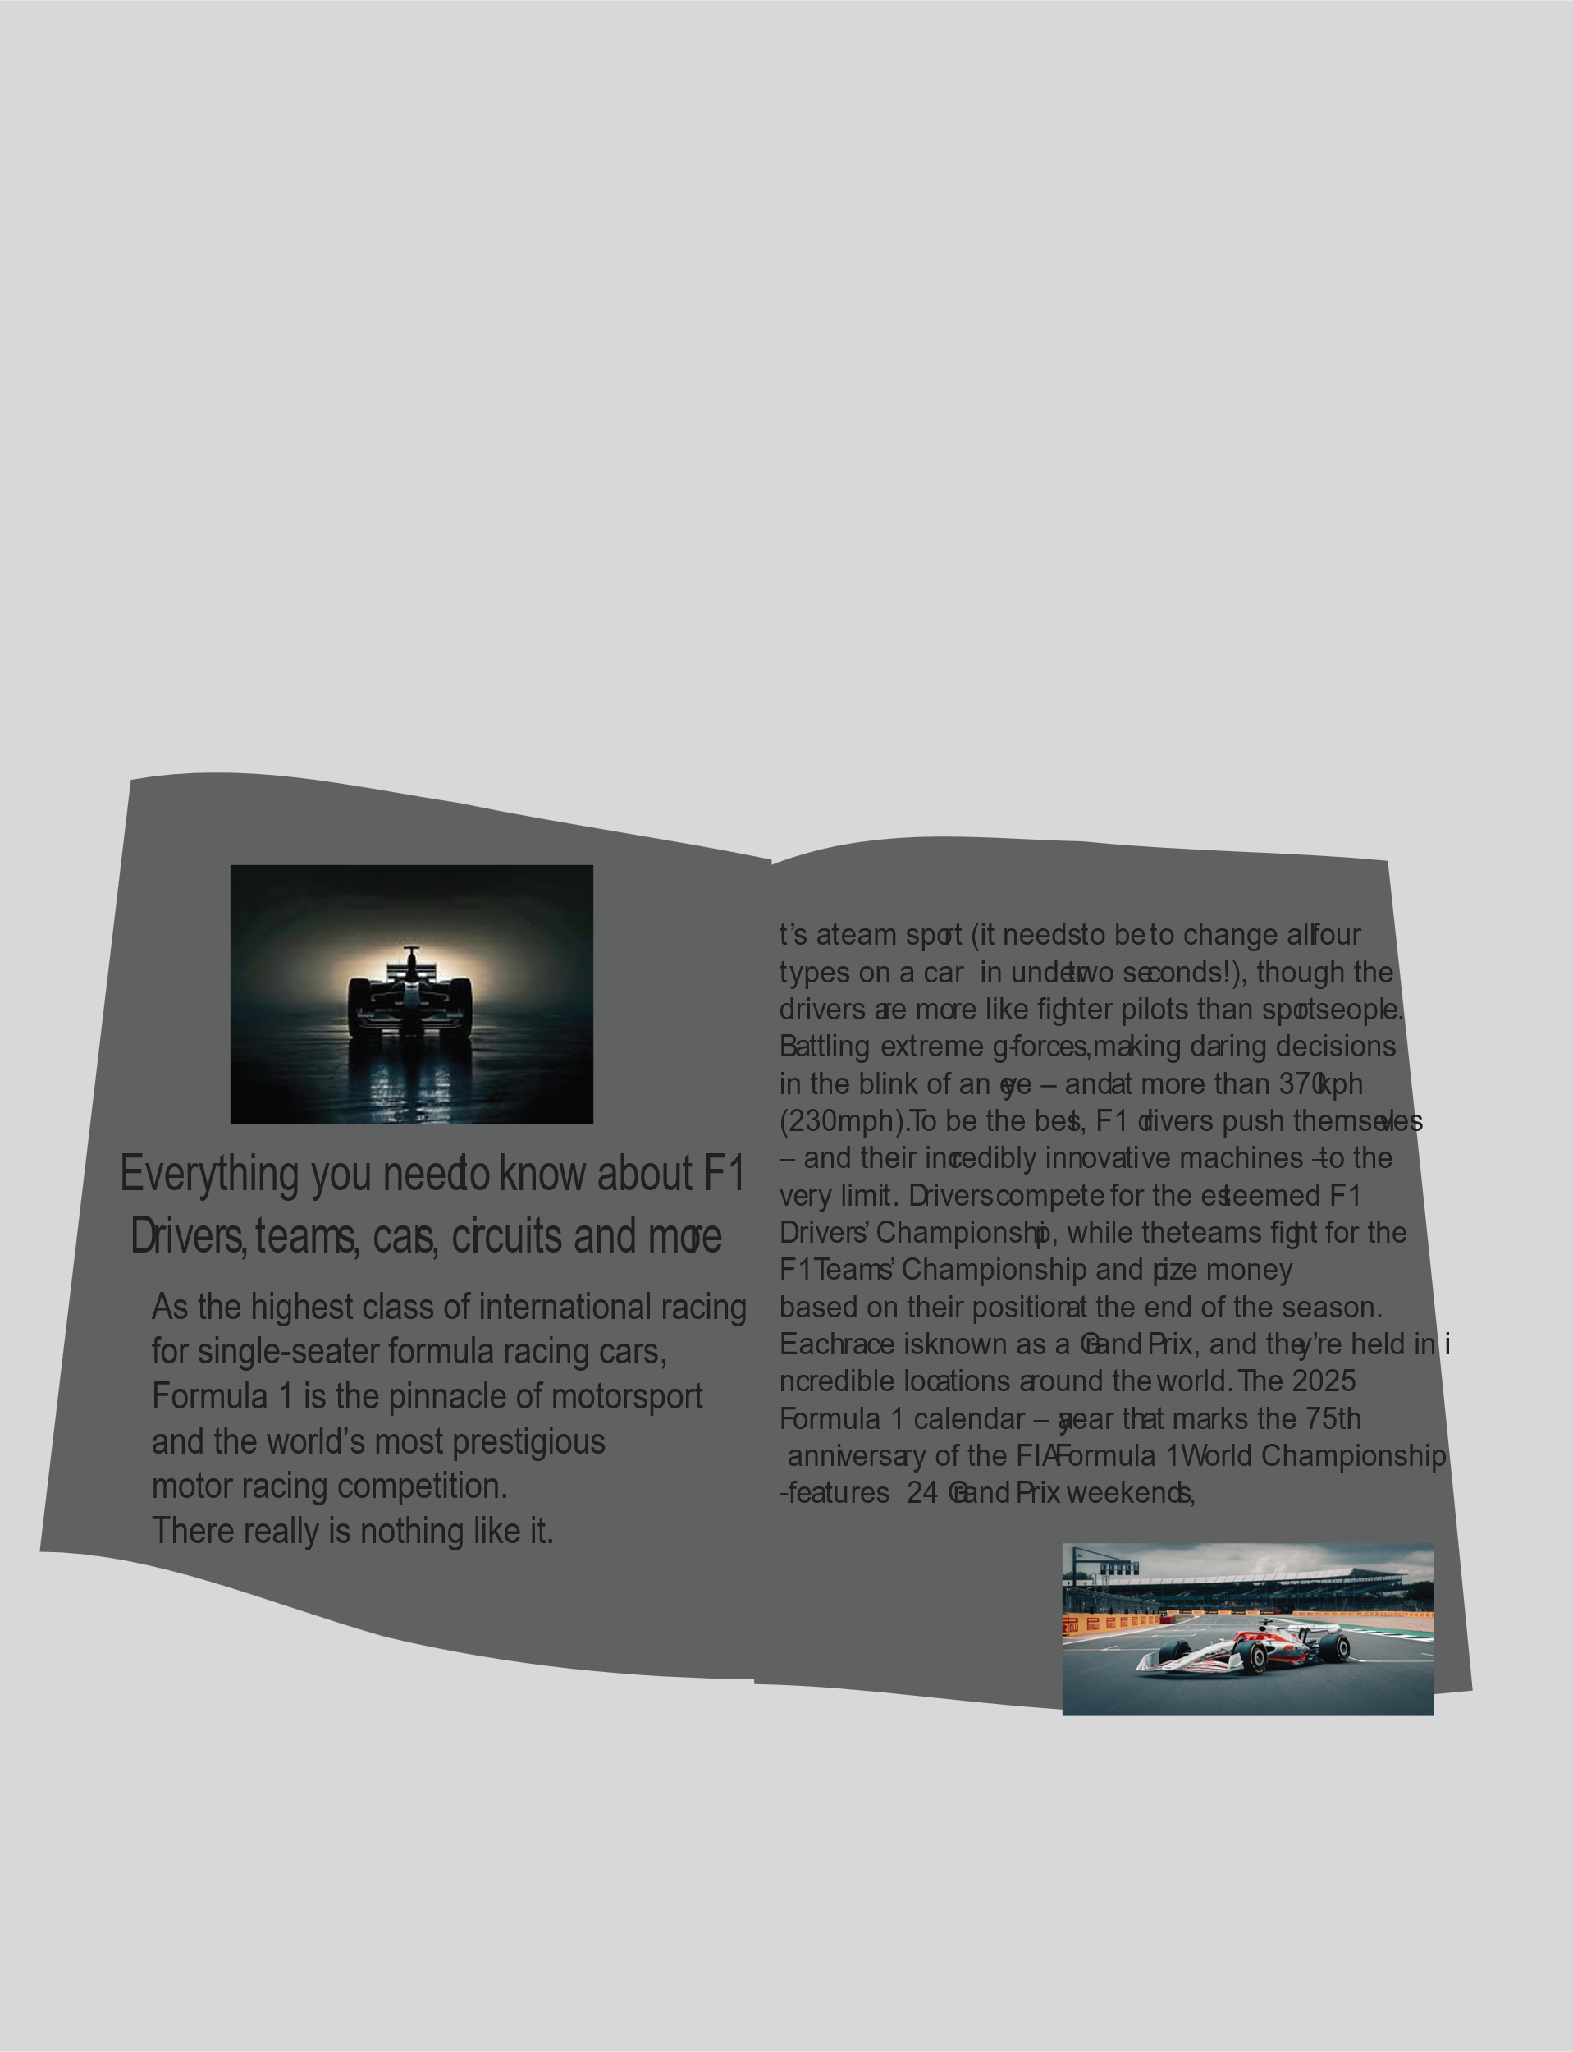

32.

